**A shared vision towards global climate justice**

After years of slow progress, international negotiations on climate and taxation issues could soon deliver a series of agreements that secure decarbonization, clamp down on tax evasion, and foster international cohesion. Such achievements may be possible by an emerging consensus on the solutions needed for climate neutrality and sustainable development.

A broad set of countries are actively cooperating to develop a transformative agenda for all the people. Under the presidencies of India and Brazil, the G20 has already delivered substantial progress. First, the African Union has joined the G20. Second, the lending headroom by Multilateral Development Banks (MDB) has increased by $400 billion over the past 18 months, with the MDBs committing that 95% of loans should have a climate-positive element. Third, the G20 is now studying a recent proposal for a minimum tax on ultra-high-net-worth individuals, which could raise up to €600 billion per year and provide resources to address climate change and poverty reduction.[1]

Recent successes can be reproduced on neighboring issues. We would like to offer a shared vision to address climate change, which translates into commonly agreed principles and instruments.

**The principles**

While decisions at the UNFCCC require unanimity, we believe that a subset of countries can work productively to propose ambitious and inclusive solutions. We further take stock that unanimity is often out of reach, despite agreement between most countries. To break the deadlocks in such situations, ambitious countries should seek non-universal agreements provided that they are fair and open to all countries.[2]

We stress the necessity of an equitable climate outcome and acknowledge the responsibility of developed countries, whose current income level stems from a historical accumulation of capital that benefited from their past emissions. Meanwhile, it is time to move beyond the simple dichotomy between developing and developed countries. Considering the huge difference of development stage compared to 30 years ago, some countries are no longer developing countries. For example, Slovenia, South Korea, Saudi Arabia, and Singapore are classified with developing countries by the UNFCCC though they are richer than Greece, which is considered developed. Instead of static, binary categories, we should use a simple yet continuous, harmonized, and up-to-date measure of development, such as GNI per capita, to define countries’ contributions and entitlements. This is already used as the basis of a range of international arrangements from eligibility to IDA loan terms to allocation of SDRs. As a benchmark (from which some adjustments can be made to account for specific cases), we believe that contributions should be proportional to a country’s GNI (partially reflecting historical emissions) while transfers should be proportional to the size of the population of a country. Of course, one could do more by asking developed countries that have emitted more since the beginning of the Industrial Revolution to contribute more but it would be less politically feasible.

We need to act *now* as any delay comes with deadly costs, disproportionately borne by low-income countries. Furthermore, such delays are inefficient from an economic point of view and they may provoke fossil fuel producers to boost extraction while the going is good (the so-called “Green Paradox”). Ensuring flows of, and access to, adequate climate finance is key to the implementation and delivery of the Paris Agreement, as well as to achieving the transition required to address the climate crisis. Developed countries should fulfill their financial commitments set out in the UNFCCC and Paris Agreement. In fact, it is in their best interest to go much further. Only by providing adequate financial conditions to developing countries can we address climate change and avoid its daunting costs.

Climate change requires responses of three types: mitigation, adaptation, and funding of losses and damages. Climate finance should be broken down accordingly. Indeed, market loans from the private sector plays a major role in mitigation and adaptation but none in losses and damages. Soft loans from development banks play a capital-heavy role in adaptation, but less so for mitigation and not at all for losses and damages. And, grants from donors play a critical role in losses and damages. The policy responses should be tailored to the specific response type. For mitigation, the key is to address capital market imperfections and lower the cost of capital in the Global South through multilateral guarantees. Adaptation is largely addressed by the recapitalization of MDBs. Lastly, increased grants are needed for adaptation and losses and damages.

The high cost of capital in developing countries remains a great challenge for mitigation and adaptation. Public finance is an indispensable lever for private finance, to swiftly mobilize private sector investment on a large scale. Public guarantees and soft loans are needed to protect investors from foreign exchange and sovereign risks. To align private incentives with the climate adaptation target, a multilateral guarantee fund could go one step further, and cut the interest rate by half for projects that reach a resilience target, as certified upon the project’s completion.

Beyond making low-carbon investments more profitable, we must also shift the current system away from fossil fuels. We should make polluters pay and progressively develop the international pricing of greenhouse gas emissions. Representative surveys from 20 countries show very strong support for climate policies that are at the global level. These surveys indicate strong majority support for a global carbon price and a consensus in favor of an equal per capita allocation of its revenue.[3]

While previous attempts of international carbon pricing have failed, this time may be different, for three reasons. First, we now know that the public at large supports a global carbon price. Second, the world population shares a common norm on how to share the revenues from a global carbon price. Third, rather than seeking universal agreement among all countries, a climate union can be formed by a broad set of ambitious countries.

**Carbon pricing**

In the short term, countries participating to the climate union would establish a carbon price floor at €10 per ton of CO2 for each country. This floor roughly corresponds to the carbon price on China’s national carbon market. A share of the carbon price revenues raised in any country would be pooled at the international level and rebated to participating countries in proportion to their population. The pooled amount would be proportional to the country’s GNI, ensuring transfers from rich countries to poor countries. The farther above the world average GNI per capita, the more a country contributes; the farther below, the more it receives. In the medium term, the climate union would establish an international competitive market for carbon permits, auctioned to fossil fuel companies upstream.

The carbon market does not imply a uniform carbon price, because some countries may choose a higher carbon price than the international one. To avoid carbon leakage in a context of differentiated prices, carbon border tax adjustments are needed. However, such tariffs should be coordinated, and their implementation overseen by a multilateral institution, to assess the carbon content and carbon price already paid on traded goods and to arbitrate disputes impartially. Besides, participating countries would commit not to tax the carbon content of imports from one another, or return the tax collected to the exporting country if they do so. This would neutralize the carbon border tax adjustments for participating countries. More than in the details of carbon tariffs, high stakes lie in the allocation of the carbon market’s emissions rights.

As a benchmark, each country would be granted emissions rights proportional to its population. There would be some adjustments to the benchmark, in line with specific needs and ambition of certain regions. China and the EU would get emissions rights corresponding to their own, ambitious decarbonization pathway. This would give more rights than the benchmark to China, and less to the EU. Such adjustments would preserve the overall ambition of the union, making it on track to meet the objective of the Paris agreement. Importantly, integrating all countries’ emissions in a common market guarantees that each country respects its target. For example, if the EU ends up emitting more than it aimed for, this will be compensated by other countries (e.g. in Africa) emitting less than the world average and selling unused emissions rights to the EU. Emissions reductions will take place where they are the least costly. To the extent that the price of carbon is higher than the price floor, additional transfers will flow from rich to poor countries, spurring much needed growth and poverty reduction in lower-income countries.

**Other instruments**

Yet, if all participating countries reduce their emissions according to their Nationally Determined Contributions (NDCs) and their long-term targets, the international carbon price will not exceed the price floor, since the climate targets of ambitious countries already align with the Paris agreement target. This situation with a non-binding quota is likely to occur in the first years of implementation. To meet the climate finance goals and provide enough financial resources to the Global South, other instruments are then needed.

Given the breadth of financing needs – climate finance should be scaled up from billions to trillions –, any innovative source is worth pursuing. A wealth tax, a financial transactions tax, a higher minimum rate on corporate income tax, an aviation or a maritime fuel levy are all good candidates.[4] They are being studied by the Global Solidarity Levies Task Force led by Barbados, France, and Kenya. Again, for each new tax, we propose that a share of revenues should be pooled at the international level and rebated to countries in need.

While allocating tax revenue in proportion to countries’ population propels the sustainable development goals, it does not address the needs for adaptation nor loss and damage. Therefore, it is advisable that at least one instrument be used to finance the latter needs. The instrument could be chosen as one that only affects the wealthiest, to not overburden ordinary people with a contribution that might not be returned to their country. In this regard, the tax on ultra-high wealth proposed by Brazil seems fit for purpose. A share of this tax could finance the Loss and Damage Fund and multilateral guarantee funds.

Table 1 and Figures 2 and 3 estimate in each country the revenue collected from the new taxes as well as the transfers between countries. Half of the tax on ultra-high wealth is assumed to finance (through a fund) countries with per capita GNI below twice the world average, in proportion to their distance to this threshold. Besides, 1% of each country’s GNI is reallocated to each country in proportion to their population. These mechanisms would entail $766 billion in North-South transfers (Figure 1), mostly borne by the richest 5%, and up to $1 trillion per year if one adds up existing Official Development Assistance. The new taxes would collect $2.1 trillion globally (Table 1), enough for all developed countries to finance their net international contribution (Figure 2). See Supplementary Material for details.

Although they still need to be amended and negotiated, we believe that the principles and instruments that we put forward can pave the way for fruitful international agreements. We hope that our proposals can contribute to a positive political tipping point where a much larger and growing group of nations work together to solve humanity’s great challenges.

Table 1. Estimate of revenue collected by new global taxes (in $ billion per year).

|  |  |  |  |  |  |  |
| --- | --- | --- | --- | --- | --- | --- |
| Wealth Tax  (3% above $100M) | Financial Transactions Tax | Carbon price floor  (10 $/tCO2) | Maritime  fuel levy  (100 $/tCO2) | Aviation  fuel levy  (300 $/tCO2) | Corporate income tax (at 21%) | **Total** |
| 765 | 327 | 356 | 104 | 223 | 299 | **2,074** |

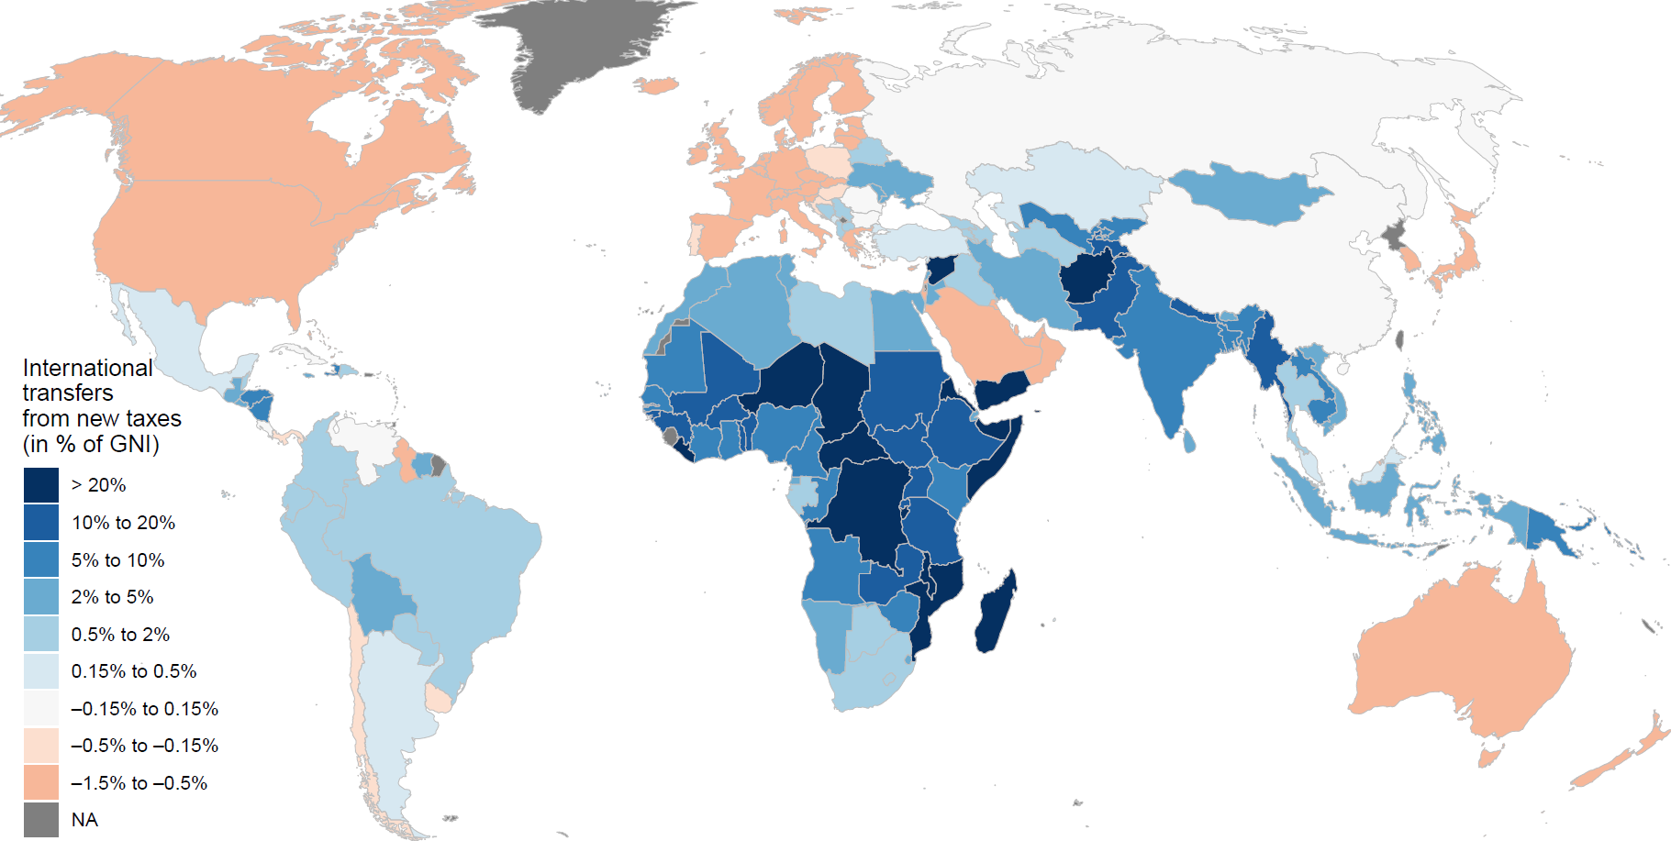

Figure 1. International transfers to be financed by new global taxes.   
The instruments proposed entail North-South transfers of $766 billion per year.

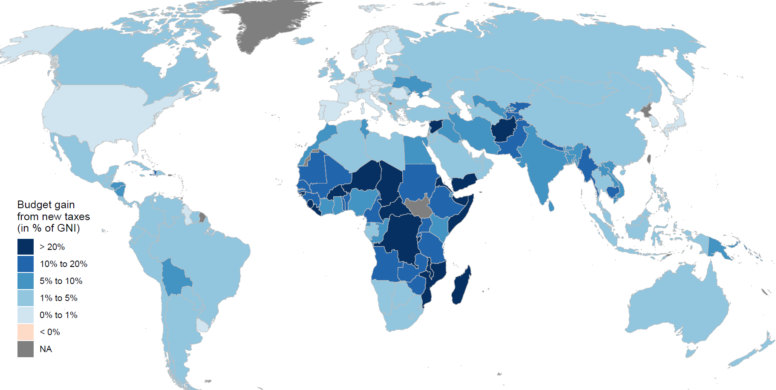

Figure 2. Net gain for state budgets from new taxes and transfers (revenue + net transfer).  
All countries’ governments gain.

1. Zucman, G. (2024). *A blueprint for a coordinated minimum effective taxation standard for ultra-high-net-worth individuals*.
2. Any unanimity rule would otherwise provide potential room for unusual (effective veto power) weights to narrow self-interests, making it difficult to reach practical solutions in large negotiating groups for common pool resource raising efforts.
3. Fabre, A., Douenne, T., & Mattauch, L. (2023). International Attitudes Toward Global Policies. *SSRN Electronic Journal*.<https://doi.org/10.2139/ssrn.4448523>
4. Our proposal for six new global taxes, taken together, would meet the desirable tax design features of: realizing overall revenue goals required for a low-carbon global commons resource pool, wider sources, consistency of rates across borders, lower rates on any single tax source, non-distortionary effects (other than addressing externalities), and equity in impact across different countries, especially with suggested allocation principles.